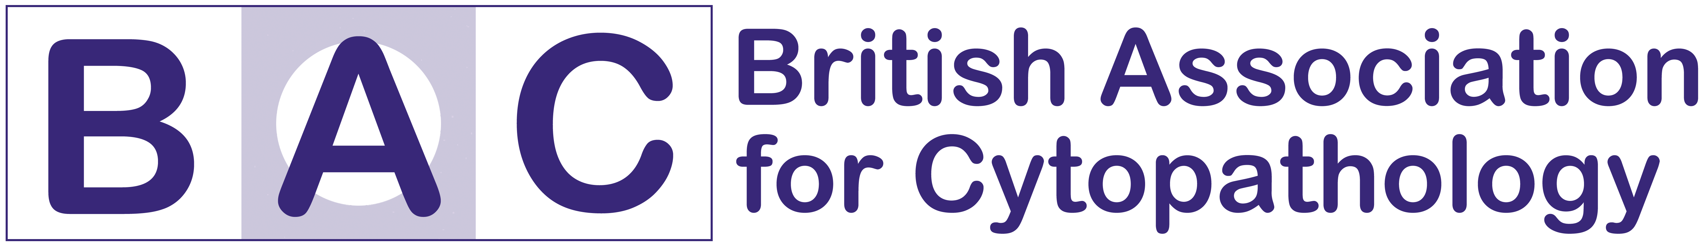

REGISTRATION FORM

BAC TUTORIAL 11th JULY 2014

HODGKIN BUILDING, KINGS COLLEGE LONDON, GUYS HOSPITAL

Payment must be attached or the option ticked for an invoice to be sent to your employer in order for your registration to be processed.

Personal Details

Title | Dr/Mr/Mrs/Miss/Ms/Other (please state)
Full Name
Contact Address
Contact Address |  | Postcode
Contact Telephone
Contact Email Address
BAC MEMBERSHIP NUMBER

Afternoon sessions

Delegates should indicate their order of preference (1-4 with 1 being the most preferred) for the afternoon sessions. These will be offered on a first come, first served basis.

Session | Preference

Urinary tract cytology

FNA liver, kidney and adrenal gland

FNA pancreas

Serous effusions

Registration Fees

Please choose from the options below:

BAC & Royal College of Pathologists Members
Before 1st April 2014 £75  
From 2nd April 2014 £100 

Non-Members
Before 1st April £100 
From 2nd April £125 

Registration fee is inclusive of morning lectures and the workshops in the afternoon plus coffee, tea and lunch.

Please indicate in the box below if you have any special dietary or medical requirements:

Payment options
  I enclose a cheque made payable to BAC

OR
 My employer will pay, please forward a purchase order request to the following address:

Completed applications and payment should be sent to:
Christian Burt
BAC
12 Coldbath Square
LONDON
EC1R 5HL

